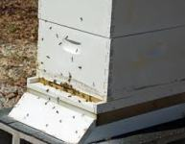 | 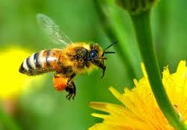 | 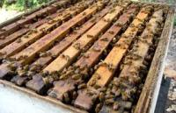
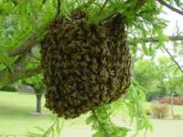 | 7th Annual  North  Alabama  Beekeepers  Symposium  August 19,  2017  Presented By:  Limestone County  Beekeepers Association  WWW.LCBEES.COM  LCBEES.AL@gmail.com | 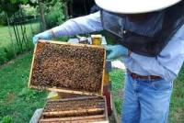
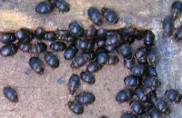 |  | 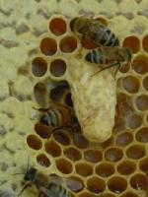
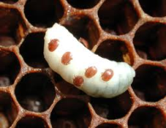 | 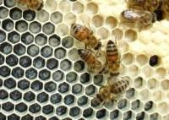 | 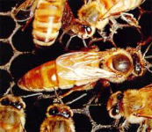
Symposium site:
Calhoun Community College
Decatur Campus
Tanner, Al.

Program

8:00 - 8:30 | Registration and Refreshments
8:30 - 8:45 | Welcome - Mr. Lionel Evans
8:45-9:15 | Dr. Jim Tew— How To Keep Bees Without All Of The Answers
9:15-9:25 | Break
9:25-10:25 | Session 1
Room | Speaker | Subject
A | Dr. Clarence Collison | Queen Biology and Problems
B | Dr. Jim Garrison | Nectar & Pollen Producing Plants
C | Mr. Phillip Garrison | Getting into Beekeeping
D | Mr. Bill Mullins | Queen Rearing - Jenter System
E | Mr. John Mynard | 10 Ways to control Varroa Mites-When & Why
10:25-10:40 | Break
10:40-11:40 | Session 2
A | Dr. Jim Tew | Varroa Treatments Again? Anything New?
B | Mr. Lonnie Funderburg | Woodenware and Frame Assembly
C | Mr. Bob Fanning & Glen Craiger | Beginning Beekeeping: 1st Year Progressive 1
D | Mr. Wil Montgomery | Queen Rearing—Cell Punch Method
E | Mr. Wes Caudle | Location and Setup of Your New Apiary
F | Mrs. Bonnie Funderburg | Lip Balms & Lotion Bars
11:40-1:00 | Lunch and Door Prizes
1:00 – 2:00 | Session 3
A | Dr. Clarence Collison | Fall Preparations
B | Dr.. Jim Garrison | Pollinator Stewardship
C | Mr. Bob Fanning & Glen Craiger | Beginning Beekeeping: 1st Year Progressive 2
D | Mr. Bill Mullins | Queen Rearing - Jenter System
E | Mr. Phillip Garrison | Harvesting Your Honey Crop
2:00-2:15 | Break
2:15- 3:15 | Session 4
A | Dr. Clarence Collison | What If?
B | Dr. Jim Tew | Small Hive Beetle….A problem?
C | Mr. Bob Fanning & Glen Craiger | Beginning Beekeeping: 1st Year progressive 3
D | Mr. Wil Montgomery | Oxalic Acid and It’s Application
E | Mr. John Mynard | Signs, Symptoms, and Pheromones in the Bee Hive

3:15-3:30 | Break
3:30-4:30 | Session 5
A | Dr. Jim Tew |  | “Beeswax—The Colony’s Building Material”
B | Mr. Randy Haman |  | What! Africanized Bees in Alabama
C | Mr. Bob Fanning & Glen Craiger |  | Beginning Beekeeping 1st Year Progressive 4
D | Mr. Wil Montgomery |  | Queen Rearing – Cell Punch Method
E | Mr. Wes Caudle |  | Location & Setup of your New Apiary
4:30 | Closing Remarks and Evaluations in Main Auditorium
Open Hive Demonstration (Weather permitting) Will Be Held From 2:15 until 3:15
Speakers
Dr. Jim Tew |  | Beekeeping Specialist, Alabama Cooperative Extension System, Auburn University and Professor Emeritus Ohio State University. Since 1975, Jim has taught classes, provided extension services, and conducted research on honey bees and honey bee behavior - specifically pollination behavior.
Dr. Clarence Collison |  | Beekeeping Specialist, Emeritus Professor/Dept. Head, Dept. of Entomology And plant Pathology,  Mississippi State University.
Philip Garrison |  | Past President Alabama Beekeepers Assn., President, Cullman County Beekeepers Assn
Dr. Jim Garrison |  | President Tennessee Beekeepers Assn., President, Middle Tennessee Beekeepers Assn. Past President Heartland Agricultural Society.
Bill Mullins |  | Queen Breeder, Member Madison Co. Beekeepers Assn, and Alabama Beekeepers Assn
Bob Fanning |  | Past President Alabama Beekeepers Assn.. Assisted by Glen Craiger, Madison Co. Beekeepers Assn.
Wil Montgomery |  | Member Alabama Beekeepers Association
Randy Hamann |  | Alabama State Apiarist, Southern Division
Todd Mullins |  | Member Limestone & Madison Co Beekeepers & Alabama Beekeepers Assn.
Lionel Evans |  | President, Limestone County Beekeepers Assn. Member Madison County & Ala. Beekeepers Assn.
John Mynard |  | Retired, Alabama State Apiarist, Northern Division. (Now Working Again!!)
Wes Caudle |  | Alabama Dept. of Agriculture and Industries, State Apiarist
Glen Craiger |  | Member Limestone and Madison County Beekeepers Associations
Mrs. Bonnie Funderburg |  | Treasurer Alabama Beekeepers Association
Mr. Lonnie Funderburg |  | President Walker County Beekeepers Assn., Past President Alabama Beekeepers Assn. Georgia Master Beekeeper

The Limestone County Beekeepers Association would like to give a special thanks to
Calhoun Community College for allowing the use of this great facility to assist us
in the education of fellow and future beekeepers.
Also, the following vendors for being here and their donations.
Walter T. Kelley Company  PO Box 240  Clarkson, KY 42726.  https://kelleybees.com/  800-233-2899 or 270-242-2012 | Dadant & Sons Inc.  51 South 2nd  Hamilton, IL 62341  http://www.dadant.com/  888-922-1293
Rossman Apiaries Inc.  P. O. Box 909  Moultrie, Georgia 31776-0909  http://www.gabees.com/  800-333-7677 | Calhoun Community College  Decatur Campus  6250 Hwy. 31 North, Tanner, AL 35671  http://www.calhoun.edu/  256-306-2500
Our open hive demonstration will be conducted  behind the  New Genesis Community Church  The map to the right is the directions  from Calhoun to the bee yard. | 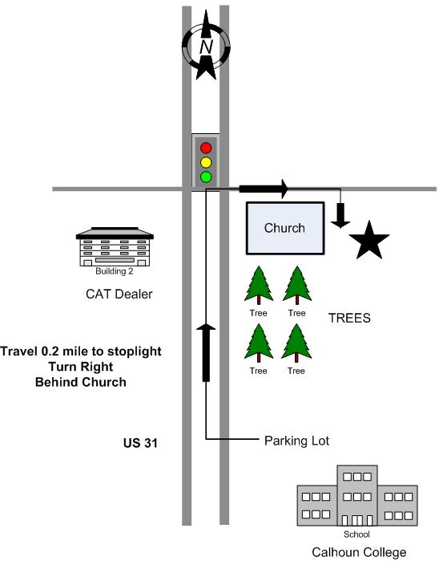
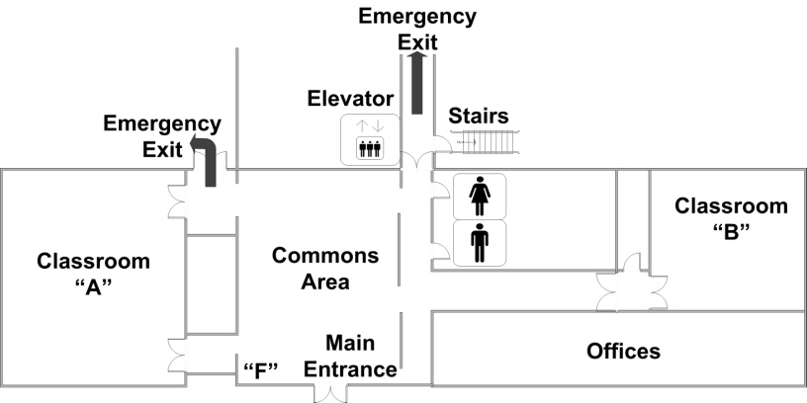 | 